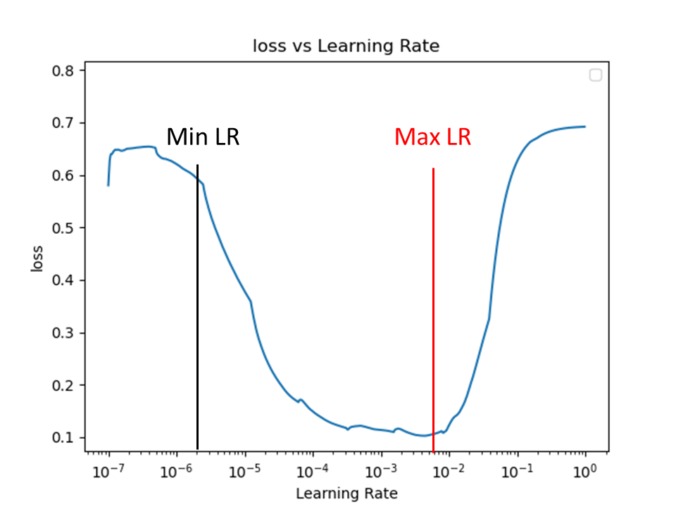
Supplementary Figure 1: Learning rate finder figure. The learning rate is gradually increased from 10e-7 to 10e-0; the point where loss begins to decrease is the minimum learning rate (min LR), and the point where it begins to increase is the maximum learning rate (max LR).

